6. Statistical Measures of Circular Distributions
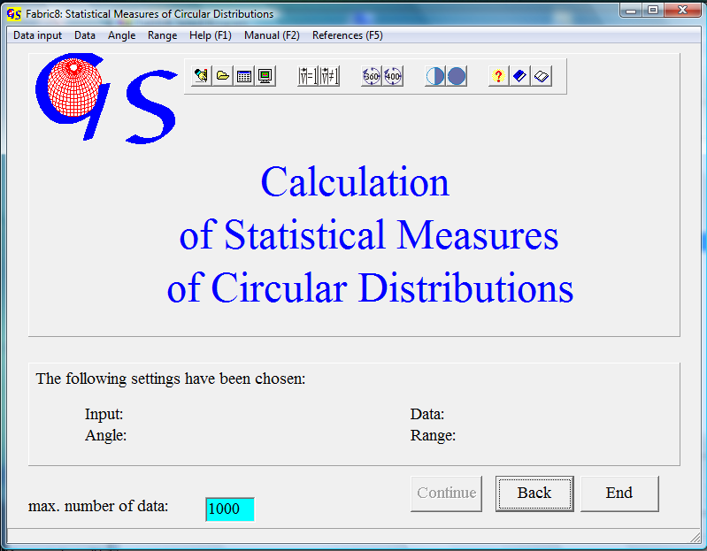
Fig. 1

This program (Fig. 1) calculates statistical measures of circularly distributed orientation data. (i.e. strike lines, lineations in remote sensing data, flow direction of rivers). The data input (Fig. 2) can be manually, from a file, from an Excel sheet, or from a picture (aerial photo, satellite image, or digital elevation model).

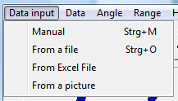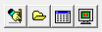
Fig. 2

In "manual input" the single values are typed. In "input from a file" files are chosen from a folder. Input from an Excel sheet is the same as in program2, 3, and 4.
When data input from an image is chosen, an aerial foto, satellite image, or other image that contains foto-lineations is displayed on the screen. The image must be a bmp, gif, tif, jpg, wmf, or emf file.
The data may be pure directions without a defined length (i.e. strike lines) or the may have a defined length (i.e. lineations on a satellite image). For this reason you have to choose the type of data in the menu “data” (Fig. 3).

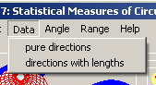 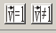 Fig. 3

When Data input is from an image, data are directions with lengths and the menu ‘data’ becomes inactive.
The menu „Range“ (Fig. 4) differentiates between data without polarity (i.e. strike lines) and those with polarity (stream lines). The first type can be described in the angular range between 1 and 180°, the second one needs 1 to 360°.
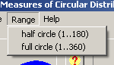 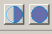 Fig. 4

The extensions for files of these different types of data are:

.STR no polarity, pure directions
.LST no polarity, Directions and lengths,
.AZI with polarity, pure directions,
.LAZ with polarity, directions and lengths.

Manual input, input from a file, and input from an Excel sheet are the same as in the previous programmes.
When you choose input from an image, the form in Fig. 5 appears. In the menu ‘import picture’ you decide whether the image is imported from the clipboard or from a bmp, gif, tif, jpg, wmf, or emf file.
The imported picture (Fig. 6) can be rotated (Menu ‘adjust picture’) in case that the north direction is not in an upright position, else you click on ‘no correction. Now data can be collected by clicking on the ends of photo-lineations with the left mouse button (Fig. 7). If you choose the range ‘half circle’, the data have no polarity, so it does not matter which end of the lineation is clicked first. In the range ‘full circle’ data are vectors with polarity. In this case click first on the vector arrows.

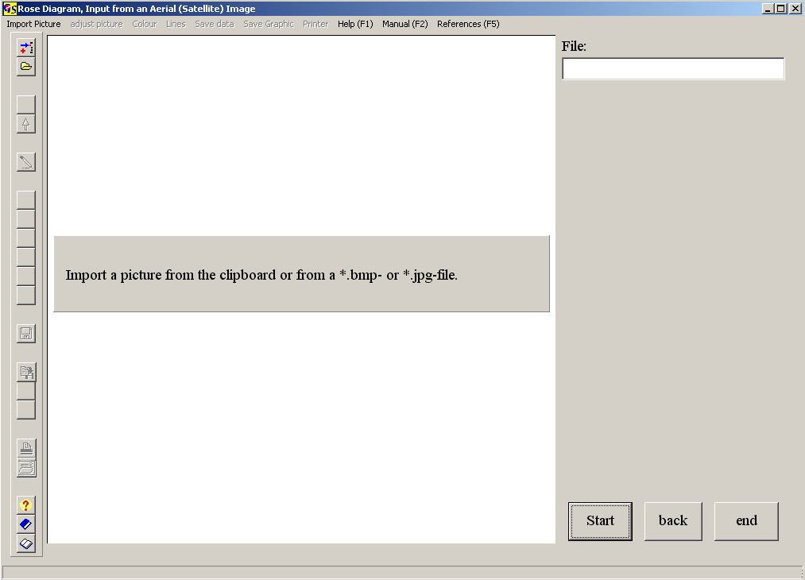
Fig. 5

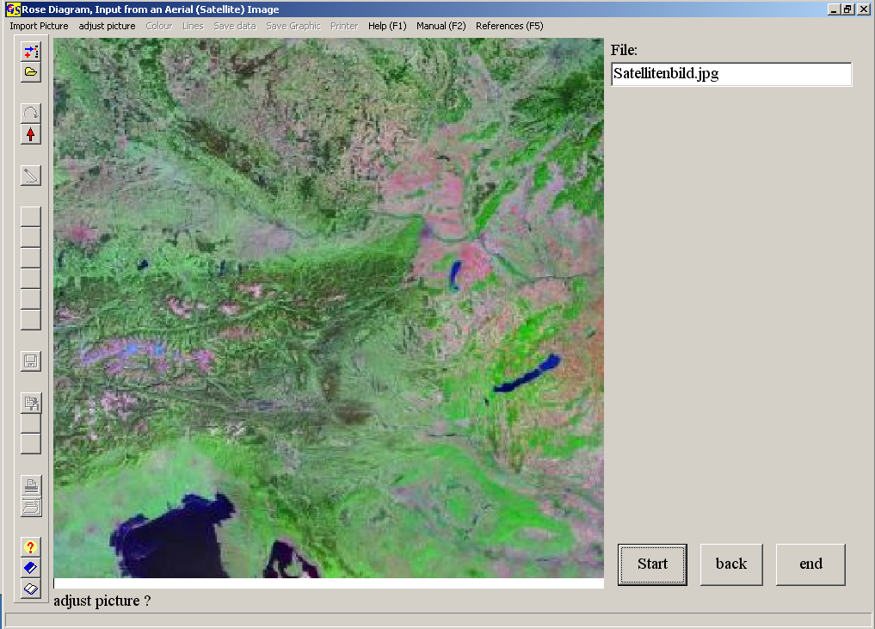
Fig. 6

The graphic can be saved and/or printed at any time.

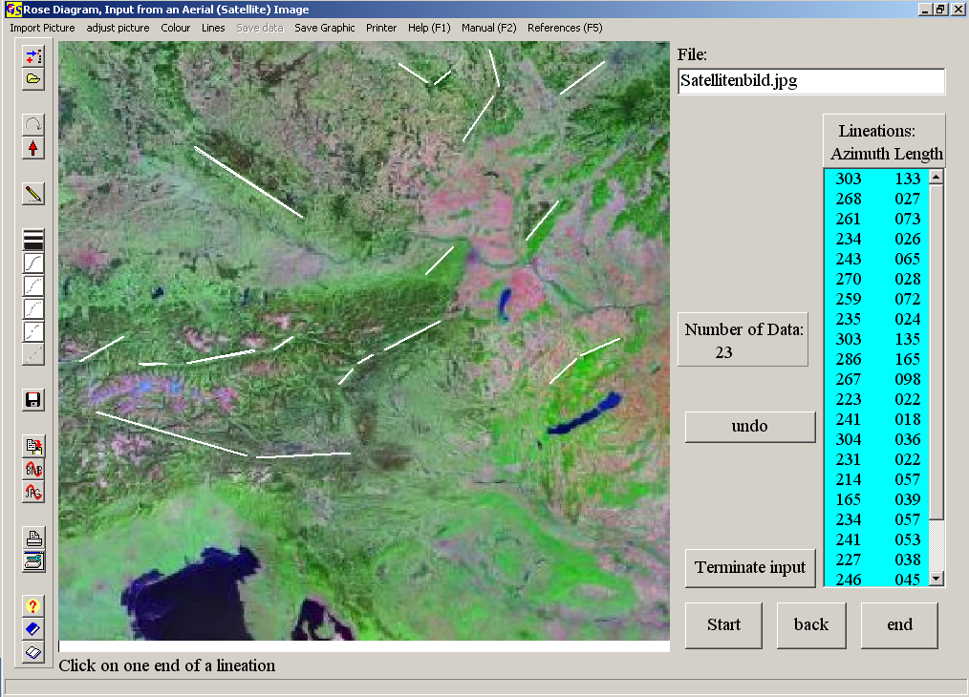
Fig. 7

After pressing the button "Terminate input" the menu "save data" is active, and the button "measures" appears. This button brings you to the next form in which the statistic parameters are shown (Fig. 8).

The following measures are calculated::
1. Vector sumSummenvektor
2. Normalized vector sum
3. Preferred orientation
4. Vector mean
5. Skewness of the distribution
6. Kurtosis of the distribution

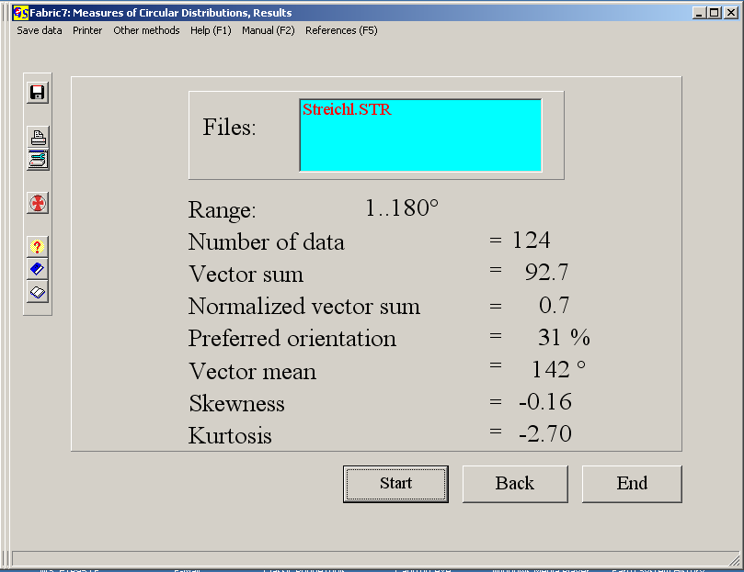
Fig. 8

The measures are calculated for a circular normal distribution, i. e. von Mises distribution (VON MISES, 1918), they are described in detail by WALLB-RECHER ( 1986:124ff).
The vector sum is the resultant length of the vectorial addition of all data:

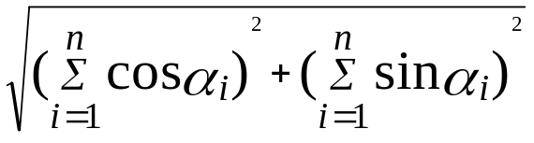

α = Azimuth

The normalizd vector sum has the form:

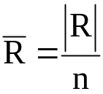
and the preferred orientation is calculated like this:

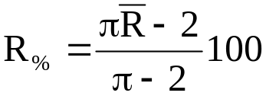

The vector mean is the direction of the vector sum. It has the form:

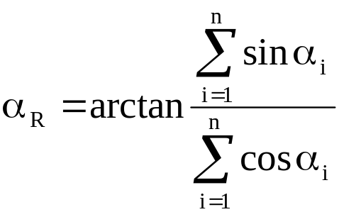
α=Azimuth

Skewness and Kurtosis have the same meaning as in normal statistics.

With The menu "Evaluation" you can jump to a rose diagram (program 7).

